**University of Petroleum and Energy Studies**

School of Computer Science

Department of Cybernetics

**Graphics & Animation Tools**

**LAB FILE**

**(Session: 2020-2021)**

Course: B.Tech with Specialization in Open Source and Open Standards

Submitted To- Submitted By-

Dr. Durgansh Sharma Nilesh

Associate Professor SAP ID -500061922

Department of Cybernetics Roll No. -R100217044

Experiment-4 Design your own animation using GIMP

Step: 1 In the process of a creation of simple animation in GIMP,First we need to have a base image and some text on top of it .the base image will remain same for all the text.

Step: 2 After Typing all the text separate them in different frames as shown in figure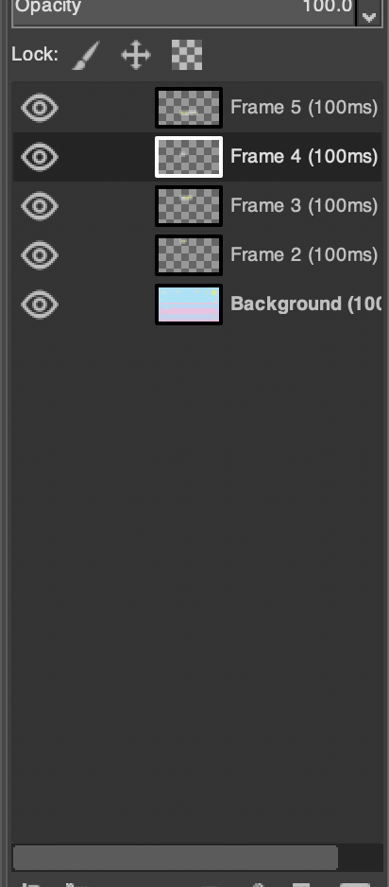

Step: 3 Now go to the settings of the gimp and export as a .gif file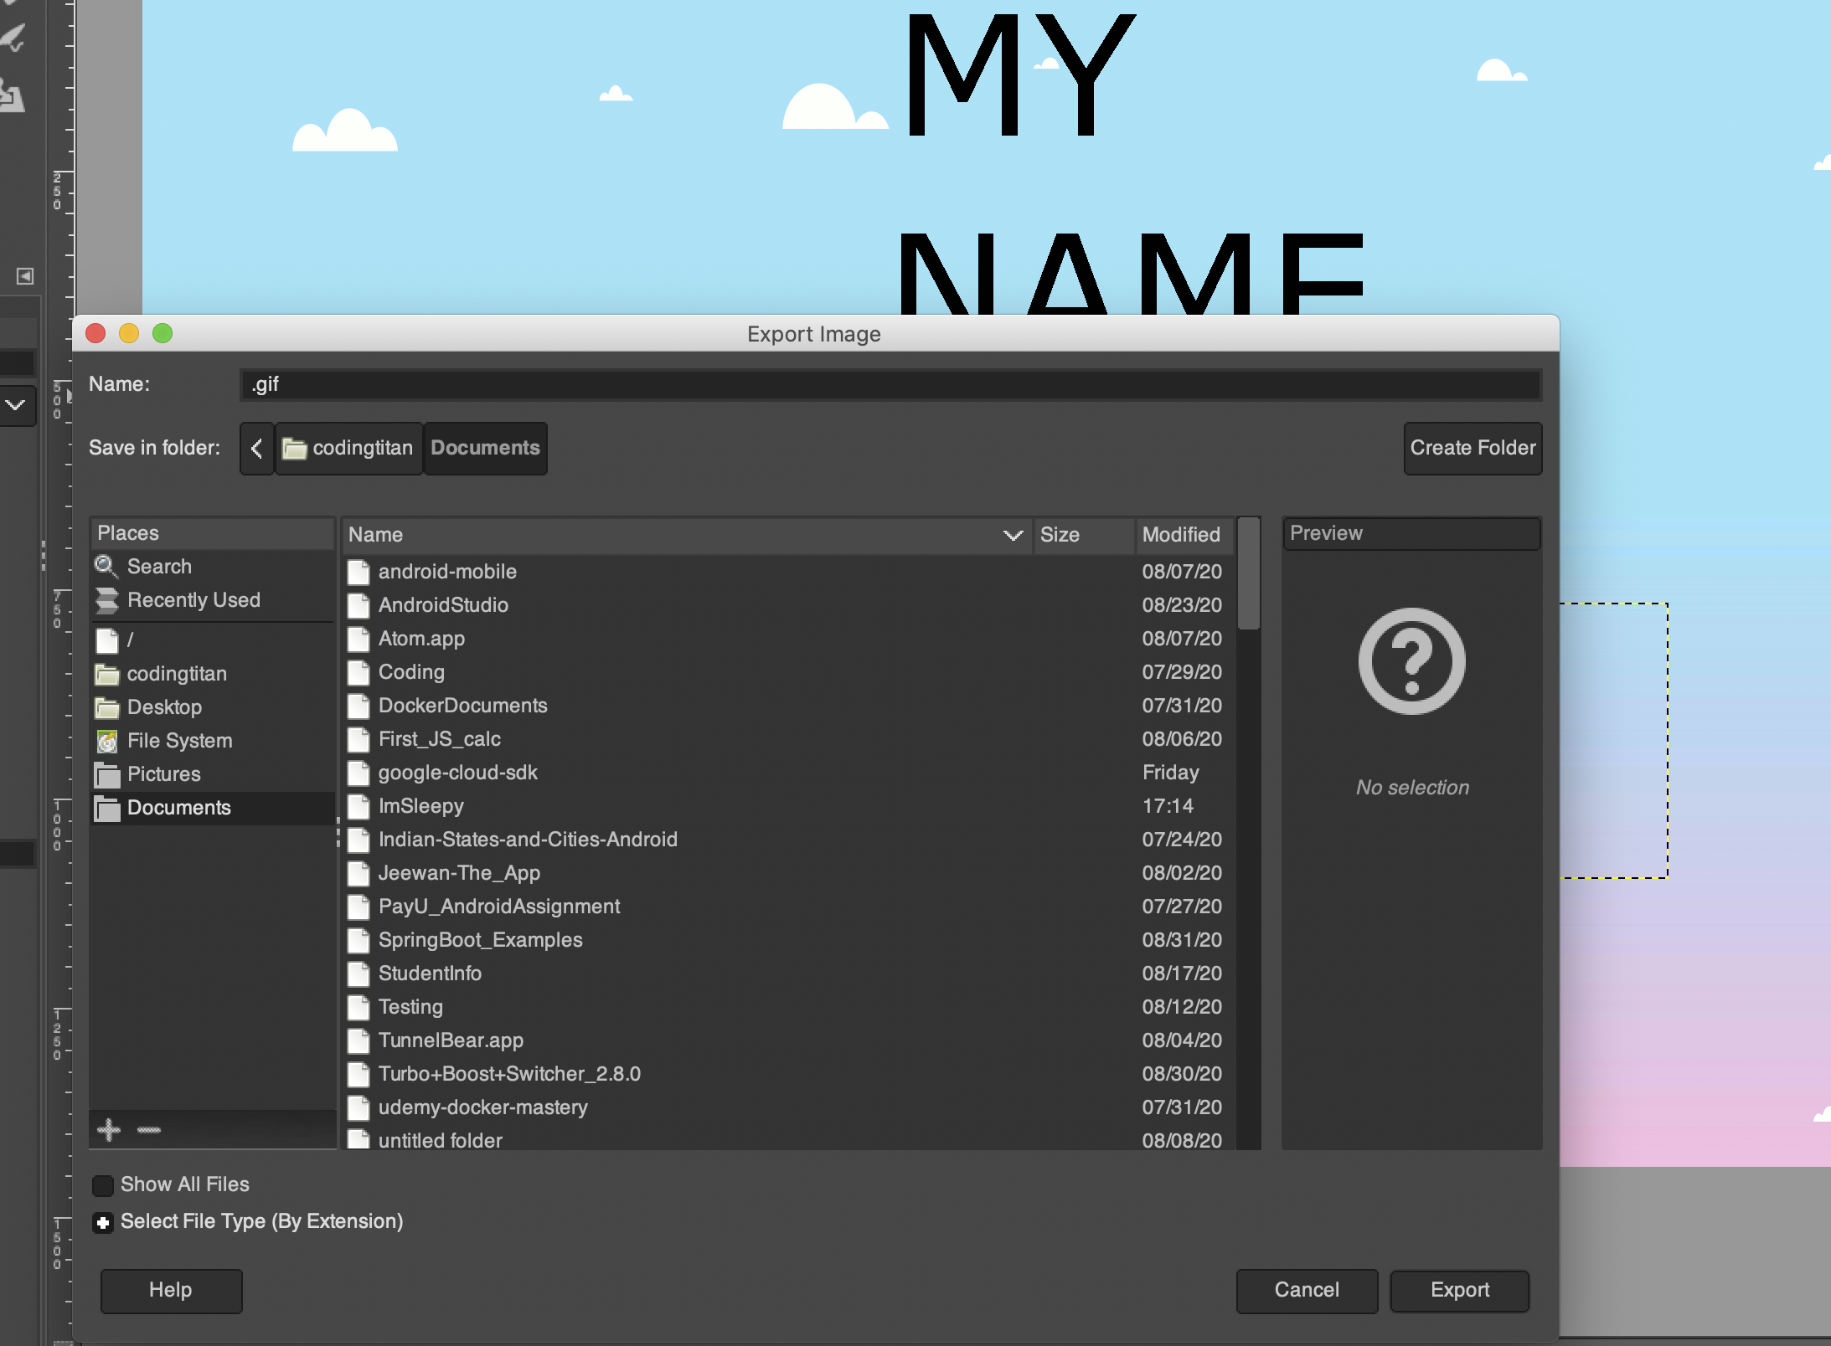

Step: 4 Now open the save file. You’ll see that your pictures of different frames are now converted into one animation as a short GIF. Fig: The final animation as a short GIF.